IJC 437 Introduction to Data Science 2025-2026

Air Quality Dynamics in Sheffield and Hull: A Data Science Approach to Environmental Analysis

Student Registration Number: 250124882

Word count: 2034

January 13, 2026



Abstract
Urban air quality is shaped by interactions between local emission sources and broader atmospheric processes, resulting in distinct pollution patterns across cities. This study examines air quality in Sheffield and Hull between 2023 and 2025, using exploratory data analysis to compare the temporal behaviour of NO₂, O₃, PM₂.₅, and PM₁₀ across contrasting environments. Open-source hourly monitoring data were cleaned and aggregated into daily, monthly, and seasonal datasets. A combination of Locally Estimated Scatterplot Smoothing (LOESS), Seasonal-Trend decomposition using LOESS (STL), and correlation analysis was used to explore short-term variability, recurring seasonal cycles, and longer-term trends.
The analysis shows that Sheffield consistently records higher NO₂ and PM₂.₅ concentrations, reflecting its traffic-dominated emission profile, while Hull exhibits higher PM₁₀ and O₃ levels, consistent with industrial activity and coastal atmospheric conditions. Both cities display strong seasonal patterns, with winter peaks in traffic-related pollutants and spring and summer peaks in ozone. Trends indicate decreasing NO₂ and rising O₃, reflecting less ozone titration due to changing emissions. Rather than focusing on prediction, the emphasis is on interpretation and comparison across multiple temporal scales.

Chapter 1

Introduction

1.1 Background and Context
Air pollution remains a major environmental and public health concern in the United Kingdom, contributing to significant illness and premature mortality each year (OHID, 2022). Pollutants such as nitrogen dioxide (NO₂), ozone (O₃), and particulate matter (PM₂.₅ and PM₁₀) are strongly associated with cardiovascular and respiratory disease, making them a central focus of national clean air strategies (DEFRA, 2023). Despite long-term emission-reduction efforts, air quality still varies between cities. These differences are influenced by local emission sources, urban layout, geography, and weather conditions.
Sheffield and Hull provide a useful comparative case. Sheffield is an inland, densely populated city where air quality is strongly influenced by road traffic and residual industrial activity (Sheffield City Council, 2010). Hull, in contrast, is a coastal port city affected by maritime transport, petrochemical industries, and enhanced atmospheric dispersion (Hull City Council, 2023). These contrasting environments make the two cities suitable case studies for examining how pollution behaves across different settings and seasons. The growing availability of monitoring data now allows these patterns to be explored in greater detail than was previously possible.

1.2 Literature Review
Previous research shows that pollutant behaviour is shaped by interactions between emission sources and atmospheric processes (Gibson et al., 2024). Seasonal effects are especially pronounced, with winter conditions often leading to elevated NO₂ and particulate matter concentrations due to reduced dispersion and increased combustion, while spring and summer sunlight promote photochemical ozone formation (Carslaw & Beevers, 2005; Monks et al., 2015).
Comparative studies also show that inland and coastal cities can exhibit distinct pollution profiles. Sicard et al. (2020) report that coastal environments often record lower NO₂ but higher ozone due to stronger ventilation and altered chemical processes. National assessments by DEFRA (2023) similarly report higher NO₂ and PM₂.₅ in traffic-dominated urban centres, while industrial and coastal regions tend to record higher PM₁₀ and O₃ concentrations.
This study builds on the existing literature by applying exploratory data science techniques to examine how these established patterns manifest in Sheffield and Hull. The focus is not on forecasting but on understanding how pollution varies over time.

1.3 Aims and Research Questions

1.3.1 Aims
To analyse and compare the temporal behaviour of NO₂, O₃, PM₂.₅, and PM₁₀ in Sheffield and Hull from 2023 to 2025 using exploratory data analysis techniques.

1.3.2 Research Questions
- How do key air pollutants vary between Sheffield and Hull from 2023 to 2025?
- What daily, monthly, and seasonal patterns can be observed in pollutant levels across the two cities?

Chapter 2

Methodology

2.1 Data Description and Methods
Hourly air-quality data for NO₂, PM₂.₅, PM₁₀, and O₃ were obtained from the OpenAQ API for Sheffield and Hull between 2023 and 2025. Data cleaning and processing were performed in RStudio and Microsoft Excel. Timestamps were standardised, duplicates removed, and missing values addressed before analysis. Hourly observations were aggregated into daily, monthly, and seasonal datasets, with seasons defined as Winter (Dec–Feb), Spring (Mar–May), Summer (Jun–Aug), and Autumn (Sep–Nov).
Exploratory Data Analysis (EDA) techniques were used to examine variability, seasonal differences, and relationships among pollutants. Given the high level of noise in the data, Locally Estimated Scatterplot Smoothing (LOESS) was applied to reveal medium-term trends. Seasonal–Trend Decomposition using LOESS (STL) was applied to the monthly series to separate trend, seasonal, and remainder components. Correlation matrices were generated to assess relationships among pollutants and to infer shared emission sources or chemical interactions.
RQ 1 is addressed by combining seasonal averages with LOESS and the long-term components extracted through STL decomposition. Together, these approaches make it possible to compare overall pollutant levels between Sheffield and Hull and to identify longer-term differences in their behaviour.
RQ 2 is addressed using daily scatter plots, monthly summaries, seasonal groupings, the seasonal components from STL decomposition, and correlation analysis. This combination highlights short-term variability, recurring seasonal cycles, and the relationships between pollutants across the two cities.
All analyses were conducted using reproducible R scripts (see Appendix and GitHub profile). The study deliberately adopted a descriptive and exploratory approach, as the research questions focused on interpretation rather than prediction.

  - Figure 2.1: Graphical Illustration of the Methodology
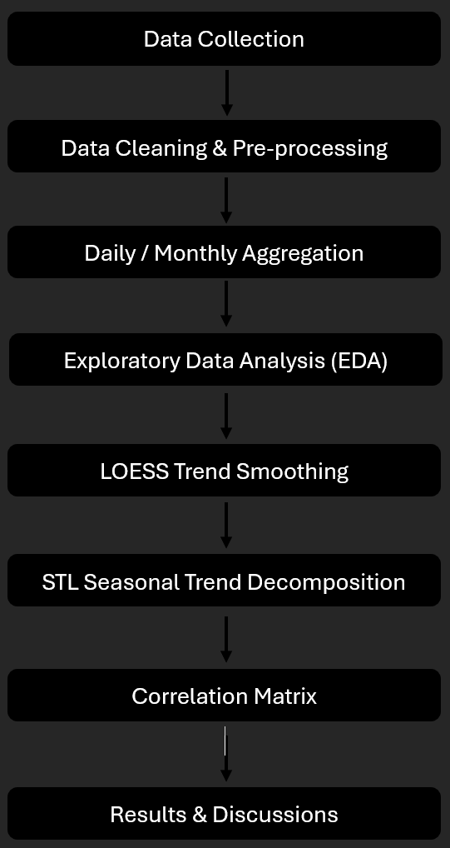

2.2 Analysis
The analysis followed a sequence of complementary steps to explore both short-term variability and longer-term trends in pollutant behaviour across Sheffield and Hull. Initial exploratory analysis revealed substantial variation in the data, including occasional outliers, and apparent differences in average pollutant levels between the two cities.
  - Table 1.0: Daily Descriptive Statistics
City | Pollutant | N | Mean | Median | Standard Deviation | Interquartile Range
Hull | NO₂ | 328 | 16.97288 | 15.32124 | 9.943372 | 10.30348
Hull | PM_{2.5} | 328 | 7.559743 | 6.434783 | 3.839238 | 4.447908
Hull | PM₁₀ | 328 | 14.48975 | 13.36364 | 5.720636 | 6.6853
Hull | O₃ | 328 | 48.62344 | 48.7533 | 15.58634 | 17.73223
Sheffield | NO₂ | 328 | 15.16099 | 12.79724 | 10.0452 | 12.90284
Sheffield | PM₂₅ | 328 | 7.045114 | 6.043478 | 3.71254 | 5.152174
Sheffield | PM₁₀ | 328 | 12.02268 | 10.86957 | 5.300609 | 6.826087
Sheffield | O₃ | 328 | 46.45978 | 46.10501 | 16.2674 | 17.77408

To make temporal patterns easier to interpret, Locally Estimated Scatterplot Smoothing (LOESS) was applied to the daily time series, revealing medium-term changes that were difficult to discern in the raw data. Seasonal Trend Decomposition using LOESS (STL) was then used to decompose each pollutant into seasonal, trend, and residual components, enabling recurring seasonal cycles to be distinguished from longer-term trends.
Relationships between pollutants were examined using correlation matrices, which provided insight into how particulate matter, nitrogen dioxide, and ozone interact within each city’s atmospheric environment. All analyses were conducted using reproducible R scripts (see Appendix). No predictive modelling was undertaken, as the study focused on describing and interpreting observed patterns rather than predicting future concentrations.

Chapter 3

Results

3.1 Exploratory Data Analysis

  - Figure 3.1: Seasonal Average Bar Plot
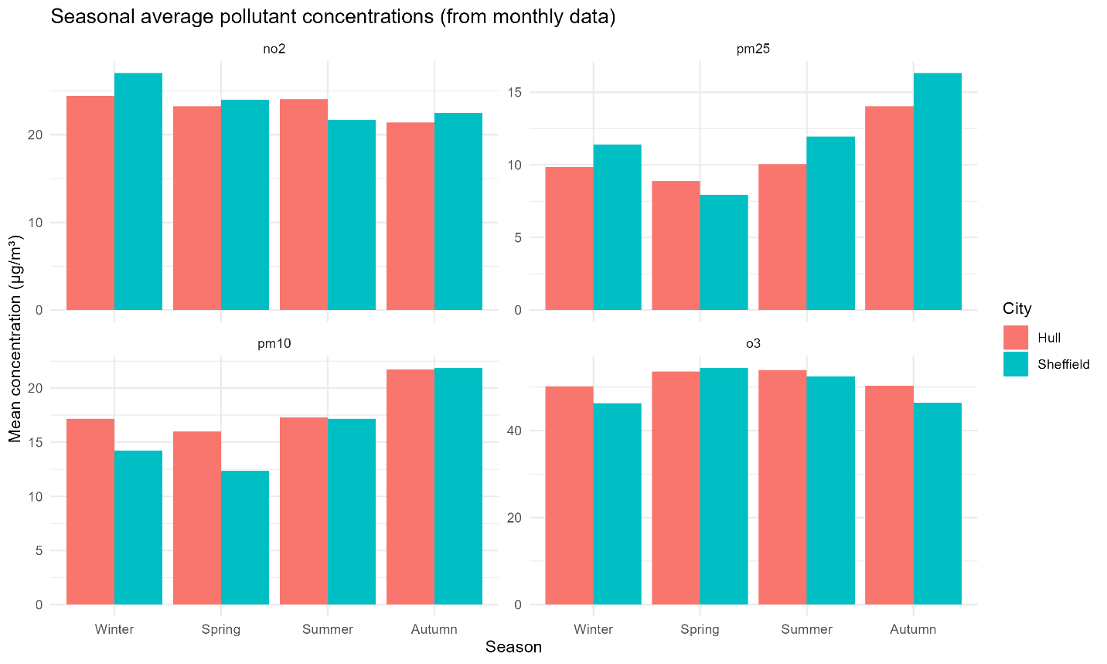

Figure 3.1 shows clear, consistent patterns across both cities. NO₂ concentrations peak in winter and reach their lowest levels in summer, with Sheffield consistently higher than Hull. This likely reflects stronger traffic influence in Sheffield. PM₂.₅ and PM₁₀ also increase during the colder months. Sheffield records higher PM₂.₅ concentrations, while Hull records higher PM₁₀ levels, consistent with differences in combustion versus industrial and port-related sources. Ozone peaks in spring and summer, with Hull generally recording higher values, possibly due to reduced ozone titration.

  - Figure 3.2: Daily Average Scatter Plot
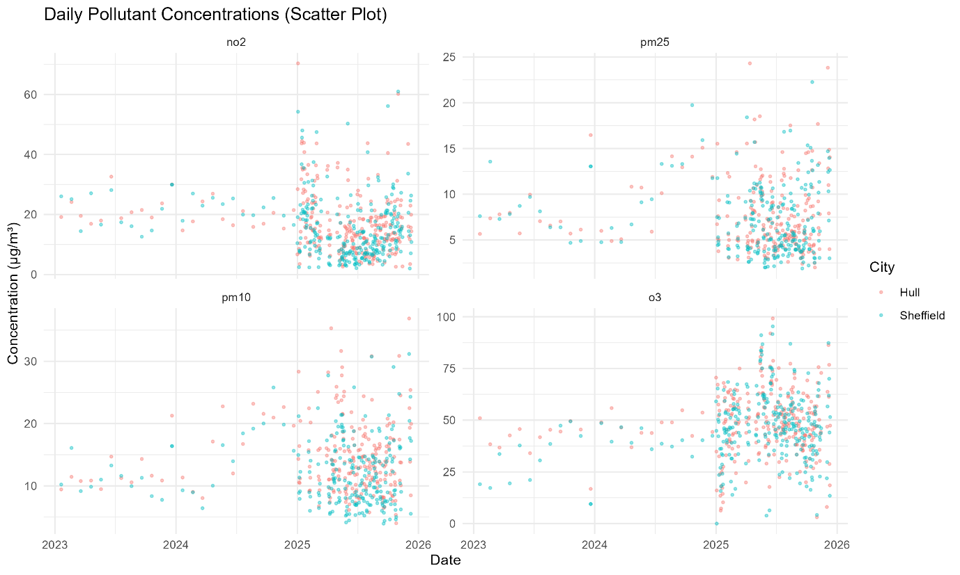

Figure 3.2 shows substantial short-term variability and occasional pollution spikes, particularly in 2025. Although both cities exhibit similar ranges of fluctuation, the density of observations makes it difficult to identify underlying trends from the raw data alone.

3.1.1 Locally Estimated Scatterplot Smoothing (LOESS)

  - Figure 3.3: LOESS Trend
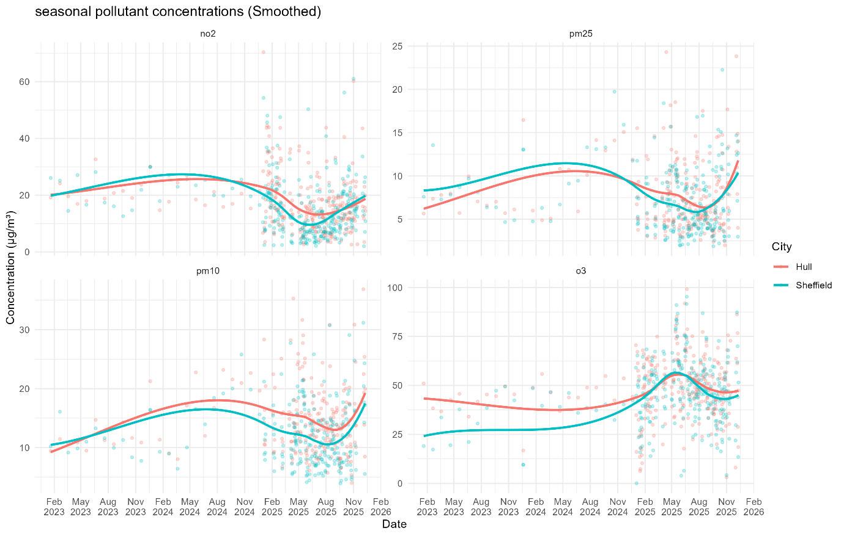

Figure 3.3 clarifies the temporal structure obscured in Figure 3.2. NO₂ concentrations decline from 2023 into late 2024, rise briefly in early 2025, and then decline again towards the end of the study period. PM₂.₅ and PM₁₀ show similar seasonal behaviour, with winter increases and summer declines. O₃ follows an opposing pattern, increasing during the warmer months and showing a gradual upward trend over time.
Compared with Figure 3.2, Figure 3.3 helps distinguish real trends from random daily fluctuations. The raw data are highly variable and erratic, especially in 2025, making it difficult to discern the direction of change. Smoothing thus provides a more precise representation of pollutant behaviour over time, confirming shared regional seasonal cycles while still emphasising differences in the emission profiles of Hull and Sheffield.

3.1.2 Seasonal Trend Decomposition using LOESS (STL)
  - Figure 3.4: STL Decomposition Hull PM₁₀
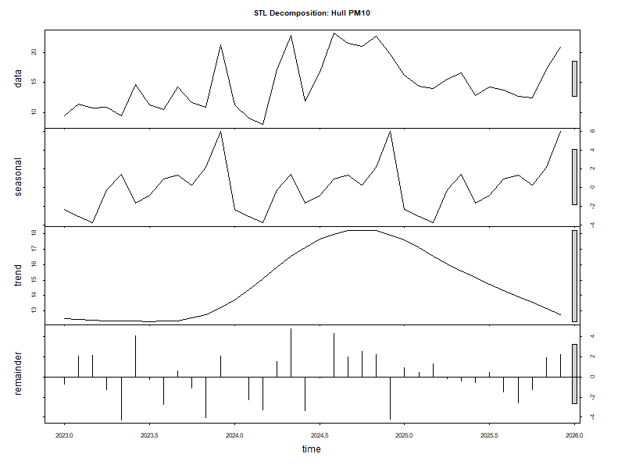

NO₂ and particulate matter display strong seasonal cycles, with winter peaks and summer lows. Ozone exhibits summer peaks and a longer-term upward trend, consistent with reduced NO₂ driven ozone titration. The remaining components are relatively small, suggesting that most variability is explained by seasonal and trend effects rather than random noise.

  - Figure 3.5: STL Decomposition Sheffield PM₁₀
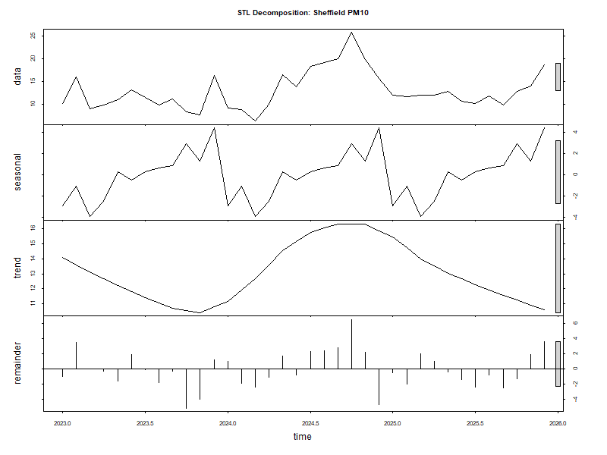

  - Figure 3.6: STL Decomposition Hull PM_{2.5}
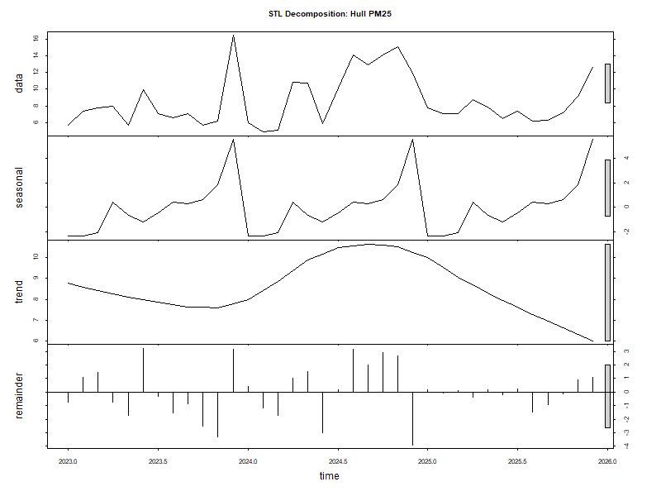

  - Figure 3.7: STL Decomposition Sheffield PM_{2.5}
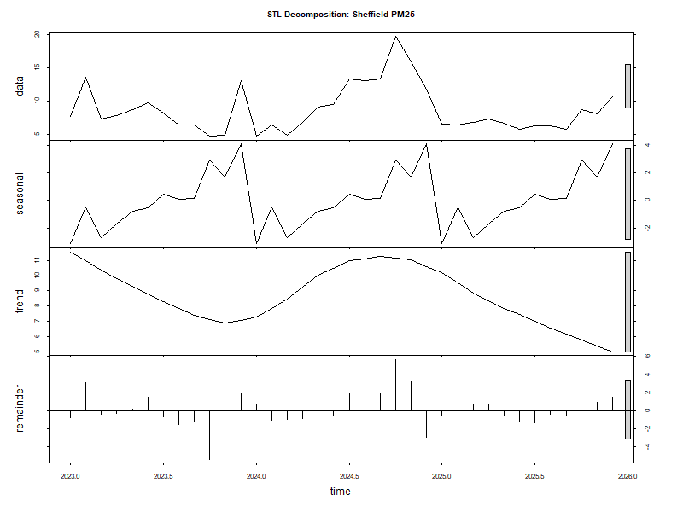

  - Figure 3.8: STL Decomposition Hull NO₂
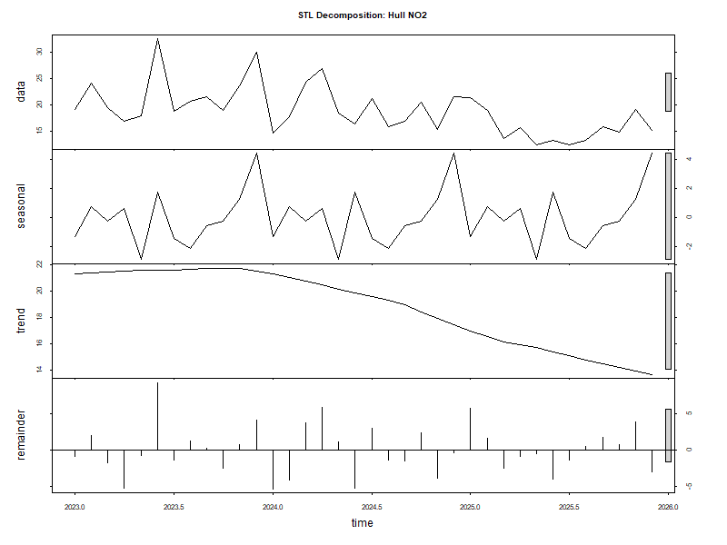

  - Figure 3.9: STL Decomposition Sheffield NO₂
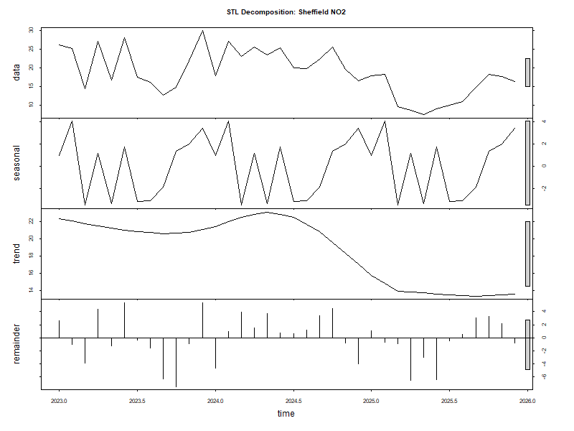

  - Figure 3.10: STL Decomposition Hull O₃
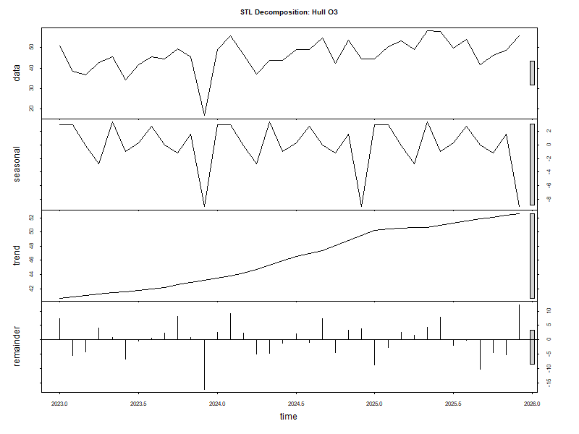

  - Figure 3.11: STL Decomposition Sheffield O₃
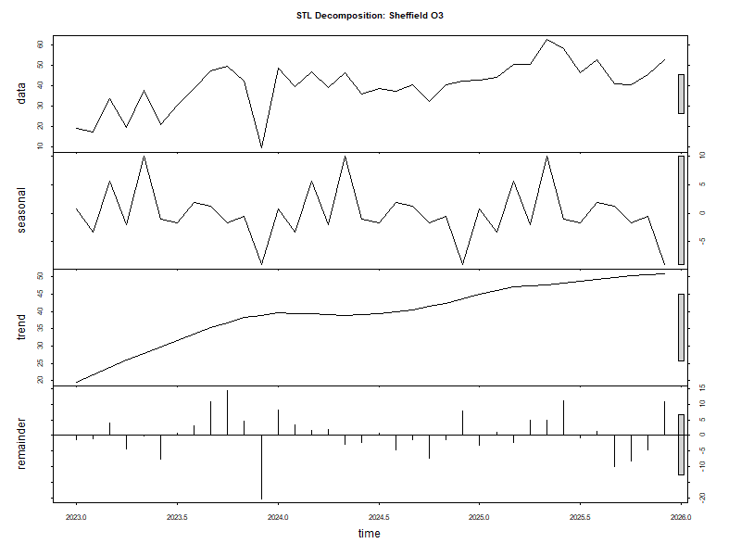

3.1.3 Correlation Matrix

  - Figure 3.12: Correlation Matrix Hull
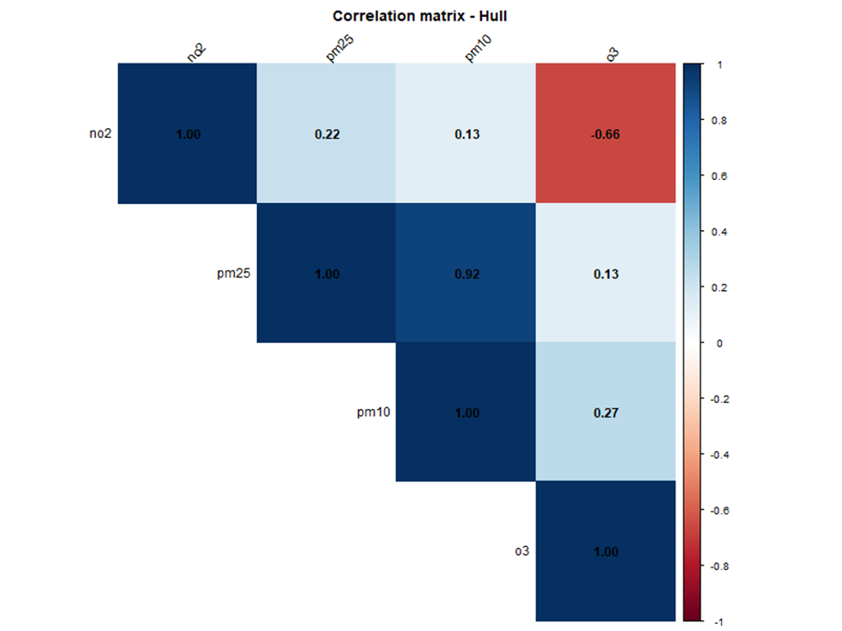

Strong positive correlations between PM₂.₅ and PM₁₀ are observed in both cities, indicating shared sources or meteorological influences. Sheffield shows moderate positive correlations between NO₂ and particulates, reflecting traffic emissions. These relationships are weaker in Hull, likely due to more diverse sources or stronger coastal dispersion. A strong negative correlation between NO₂ and O₃ in both cities reflects established photochemical titration processes.

  - Figure 3.12: Correlation Matrix Sheffield
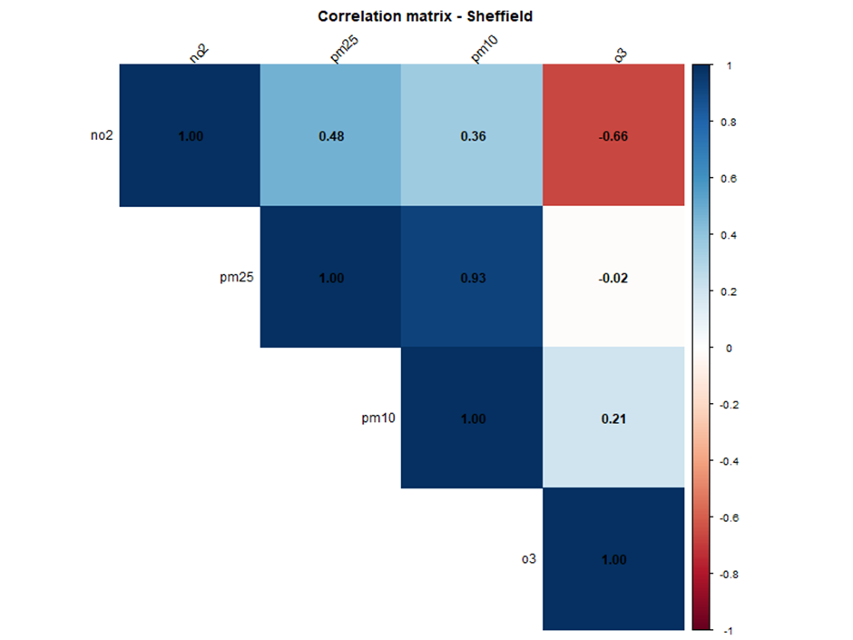

3.2 Discussion
The use of LOESS and STL decomposition proved essential for interpreting the data. These techniques enabled the separation of trends from short-term noise and the identification of seasonal patterns. Correlation analysis further supported existing chemical principles, particularly the strong relationship between particulates and the inverse relationship between NO₂ and O₃.

3.2.1 Answering the Research Questions

3.2.1.1 How do key air pollutants vary between Sheffield and Hull from 2023 to 2025?

Overall, Sheffield consistently recorded higher NO₂ and PM₂.₅ concentrations, while Hull generally exhibited higher PM₁₀ and O₃ levels. These differences reflect contrasting emission profiles and environmental settings. Sheffield’s elevated NO₂ and PM₂.₅ are likely linked to higher traffic density and combustion sources, whereas Hull’s higher PM₁₀ and ozone appear influenced by industrial activity, maritime sources, and coastal atmospheric conditions. Although NO₂ declined in both cities over time, Sheffield remained consistently higher, whereas ozone gradually increased, with Hull maintaining higher levels throughout.

3.2.1.2 What daily, monthly, and seasonal patterns can be observed in pollutant levels across the two cities?
Daily pollutant concentrations exhibit significant short-term fluctuations and occasional spikes in both cities, primarily driven by weather conditions and temporary events. A clearer structure emerges at monthly and seasonal scales, with NO₂, PM₂.₅, and PM₁₀ peaking in winter and declining in summer, reflecting increased cold-season emissions and reduced dispersion. Ozone follows an opposing cycle, with higher concentrations in spring and summer due to enhanced photochemical activity. STL decomposition confirms that strong seasonal cycles account for much of the variability, while correlation analysis highlights consistent relationships among pollutants, particularly the negative association between NO₂ and O₃.

3.2.2 Relation to Existing Research
The results of this study are broadly consistent with existing research on air quality in the UK. Sheffield’s higher NO₂ and PM₂.₅ concentrations align with findings that traffic-dominated inland cities tend to experience elevated concentrations of combustion-related pollutants (Carslaw & Beevers, 2005; DEFRA, 2023). In contrast, Hull’s higher PM₁₀ and ozone levels reflect patterns commonly reported in coastal and industrial cities, where enhanced atmospheric mixing and reduced NO₂ titration influence pollutant behaviour (Monks et al., 2015; Sicard et al., 2020).
The distinct seasonal patterns observed in both cities align with known atmospheric processes, showing winter peaks in NO₂ and particulate matter, and spring-to-summer peaks in ozone driven by photochemical activity (WHO, 2021). The concurrent decline in NO₂ and rise in ozone further support previous evidence that changes in nitrogen oxide emissions can alter ozone chemistry. Overall, the findings reinforce the existing literature while highlighting the role of environmental context in shaping pollution patterns.

Chapter 4

GitHub
As part of the project workflow, all R scripts, datasets, and visualisation figures were uploaded to a GitHub repository. The repository was organised for easy navigation, with separate sections for the IJC437 and IJC445 project pages, and a code directory containing well-commented R scripts. Clear instructions for running the analysis were also included.
GitHub repository: https://github.com/tanure1999/Air-Quality-Analysis-Sheffield-Hull-2023-2025
  - Figure 4.1: GitHub Repo Page


Chapter 5

Conclusion
This study reveals clear seasonal patterns, distinct city-level pollution profiles, and consistent relationships among key pollutants. Sheffield consistently recorded higher NO₂ and PM₂.₅ concentrations, reflecting traffic and combustion emissions, while Hull recorded higher PM₁₀ and slightly elevated ozone levels, consistent with industrial activity and coastal dispersion. Both cities exhibited strong seasonality, with winter peaks in NO₂ and particulate matter and summer peaks in ozone. Longer-term trends indicate declining NO₂ alongside a gradual rise in ozone, aligning with established atmospheric chemistry and changing emission policies.
The analysis was limited by uneven data coverage, reliance on a single monitoring station, and the potential masking of short-term pollution patterns through aggregation. Future work could integrate meteorological variables, include additional monitoring sites, and extend the analysis using predictive approaches. Overall, the study demonstrates how combining statistical analysis with domain knowledge supports the interpretation of air-quality data.

Reference
Carslaw, D. C., & Beevers, S. D. (2005). Estimations of road vehicle primary NO₂ exhaust emission fractions using monitoring data in London. Atmospheric Environment, 39(1), 167–177. https://doi.org/10.1016/j.atmosenv.2004.08.053
Cairo, A. (2016). The truthful art: Data, charts, and maps for communication. New Riders.
Cleveland, W. S., & McGill, R. (1984). Graphical perception: Theory, experimentation, and application to the development of graphical methods. Journal of the American Statistical Association, 79(387), 531–554. https://doi.org/10.1126/science.229.4716.828
Department for Environment, Food & Rural Affairs (DEFRA). (2023). Air quality statistics in the UK. UK Government. https://www.gov.uk/government/statistics/air-quality-statistics
Few, S. (2012). Show me the numbers: Designing tables and graphs to enlighten (2nd ed.). Analytics Press.
Hull City Council. (2023). Air quality annual status report (ASR).
Monks, P. S., Archibald, A. T., Colette, A., Cooper, O., Coyle, M., Derwent, R., Fowler, D., Granier, C., Law, K. S., Mills, G. E., Stevenson, D. S., Tarasova, O., Thouret, V., von Schneidemesser, E., Sommariva, R., Wild, O., & Williams, M. L. (2015). Tropospheric ozone and its precursors from the urban to the global scale from air quality to short-lived climate forcer. Atmospheric Chemistry and Physics, 15(15), 8889–8973. https://doi.org/10.5194/acp-15-8889-2015
OpenAQ. (2024). OpenAQ platform: Open air quality data. https://openaq.org

Sheffield City Council. (2010). Air quality in Sheffield.
https://www.sheffield.gov.uk/pollution-nuisance/air-quality
Sicard, P., De Marco, A., Agathokleous, E., Feng, Z., Xu, X., Paoletti, E., & Calatayud, V. (2020). Amplified ozone pollution in cities during the COVID-19 lockdown. Science of the Total Environment, 735, 139542. https://doi.org/10.1016/j.scitotenv.2020.139542
Ware, C. (2013). Information visualisation: Perception for design (3rd ed.). Morgan Kaufmann.
World Health Organisation (WHO). (2021). WHO global air quality guidelines: Particulate matter (PM₂.₅ and PM₁₀), ozone, nitrogen dioxide, sulphur dioxide and carbon monoxide.
https://www.who.int/publications/i/item/9789240034228
World Wide Web Consortium (W3C). (2018). Web Content Accessibility Guidelines (WCAG) 2.1. https://www.w3.org/TR/WCAG21/

Appendix
  - 7.1: Install & Load Packages
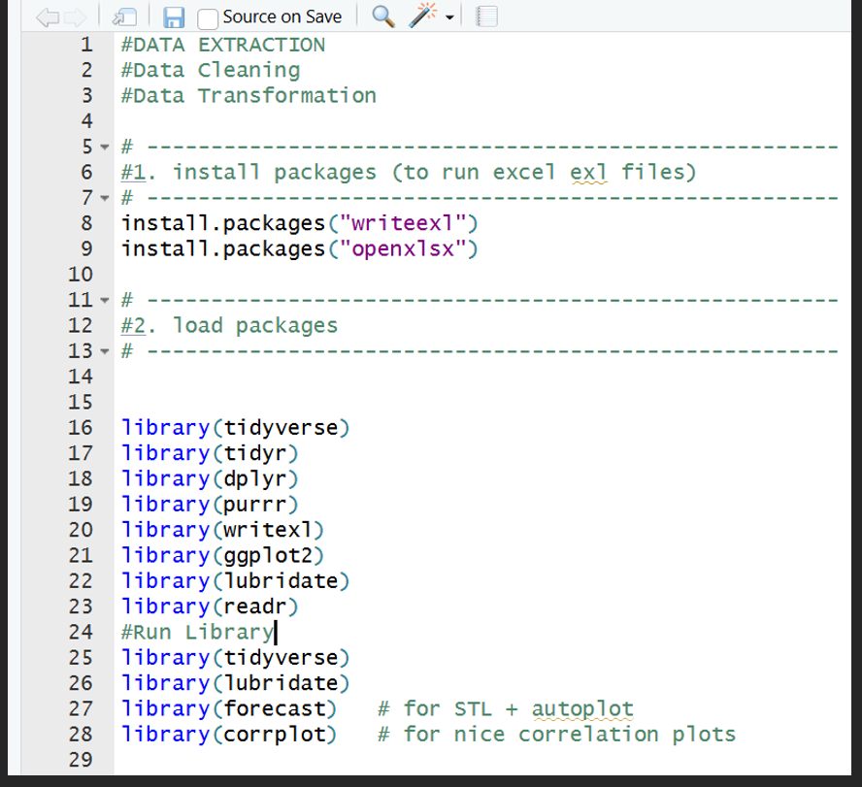

  - 7.2: Quick Plot Test After Data Cleaning
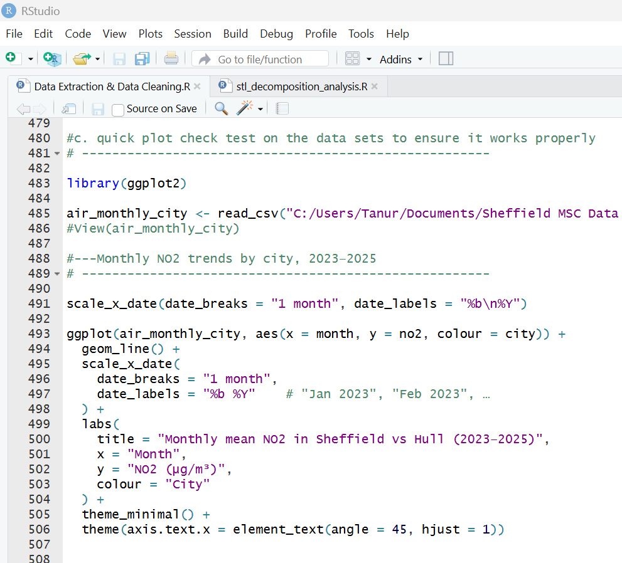
  - 7.3: CSV(not all) Files after Data Extraction & Cleaning
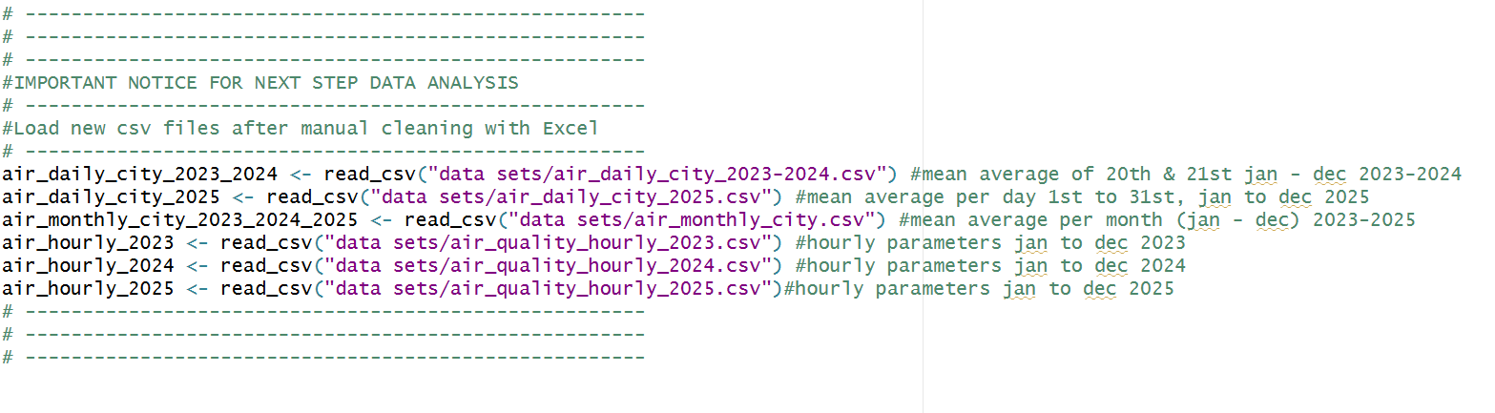

  - FIG 7.4: Load Aggregated CSV Files
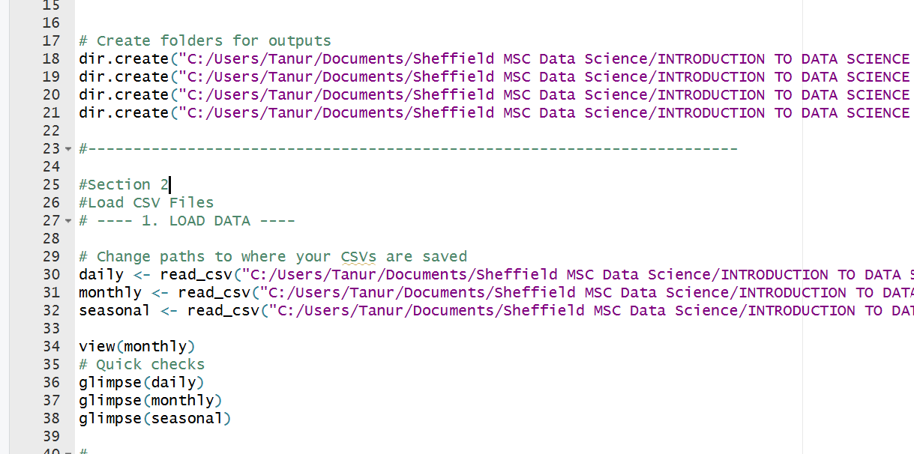
  - FIG 7.5: Standardising Date Columns
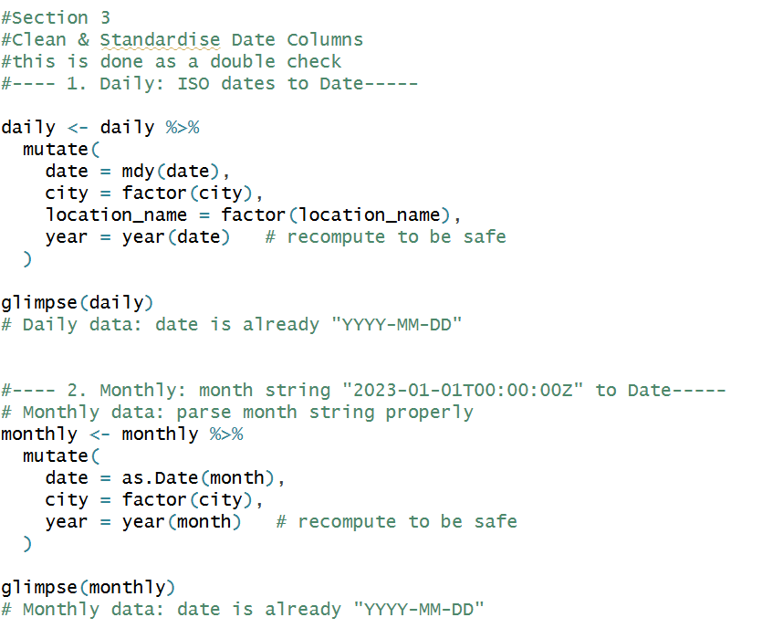

  - FIG 7.6: Seasonal Bar Plot
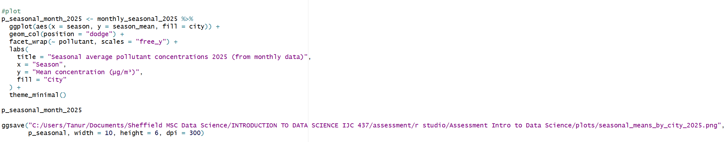
FIG 7.7: Scatter Plot
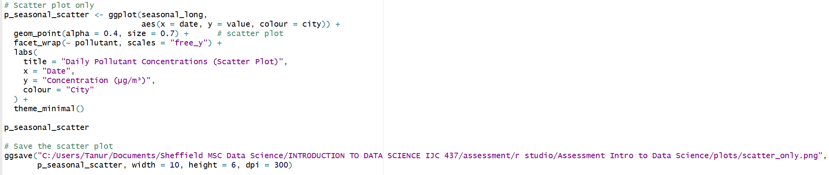
  - FIG 7.8: LOESS Plot
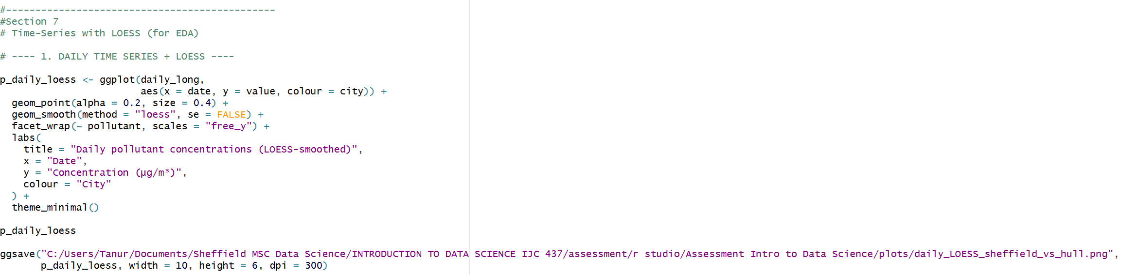

  - FIG 7.9: STL Decomposition using LOESS
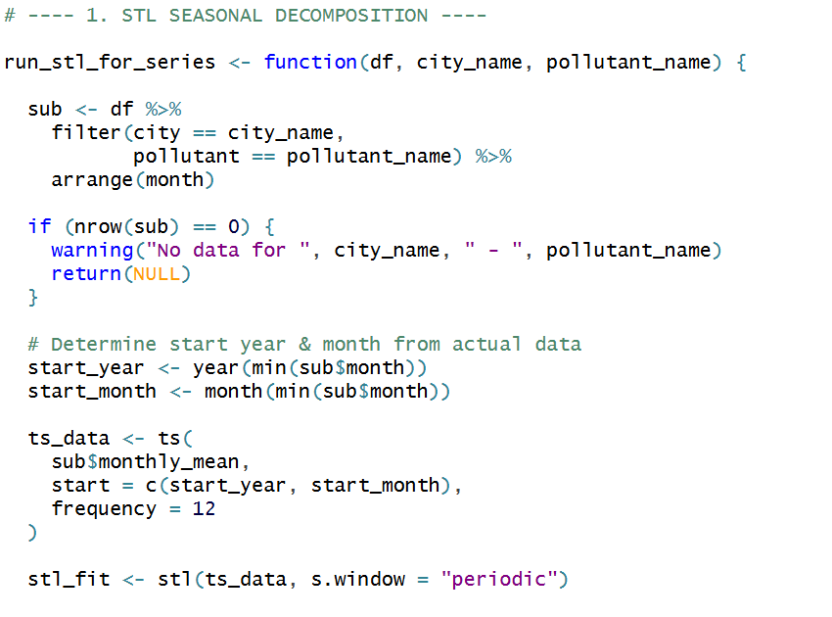
  - FIG 7.10: STL Decomposition using LOESS (ctd)
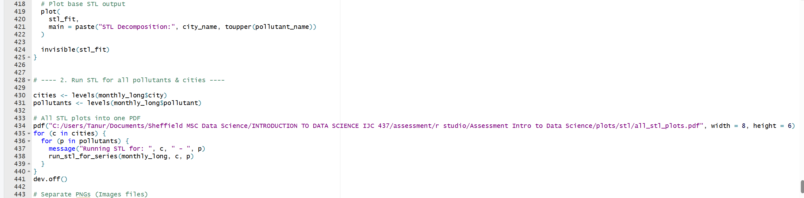

  - FIG 7.11: Correlation Matrix Plot
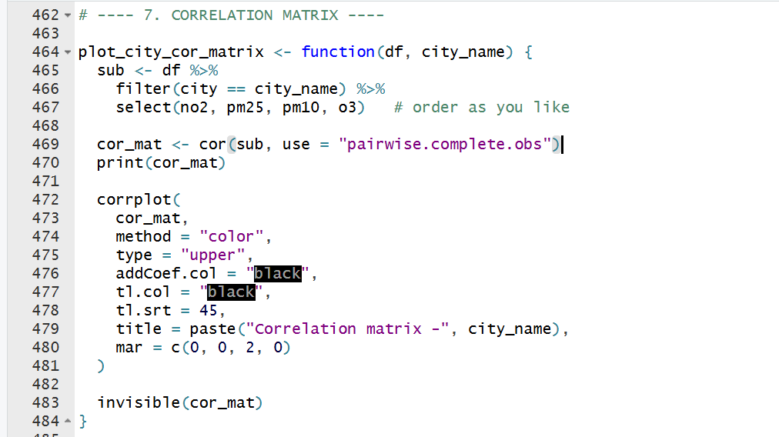
  - FIG 7.12: Correlation Matrix Plot (ctd)